**Exploratory Data Analysis**

In [statistics](https://en.wikipedia.org/wiki/Statistics), exploratory data analysis is an approach of [analyzing](https://en.wikipedia.org/wiki/Data_analysis) [data sets](https://en.wikipedia.org/wiki/Data_set) to summarize their main characteristics, often using [statistical graphics](https://en.wikipedia.org/wiki/Statistical_graphics) and other [data visualization](https://en.wikipedia.org/wiki/Data_visualization) methods. A [statistical model](https://en.wikipedia.org/wiki/Statistical_model) can be used or not, but primarily EDA is for seeing what the data can tell us beyond the formal modeling or hypothesis testing task.

We are using a dataset ,but in this dataset we have considered for the whole day,even during night hours

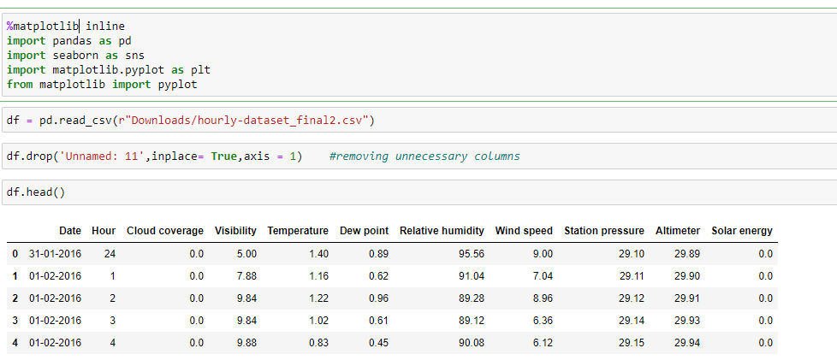

**Pairplot**

Pairplot visualizes given data to find the relationship between them where the variables can be continuous or categorical. Plot pairwise relationships in a data-set. Pairplot is a module of seaborn library which provides a high-level interface for drawing attractive and informative statistical graphics

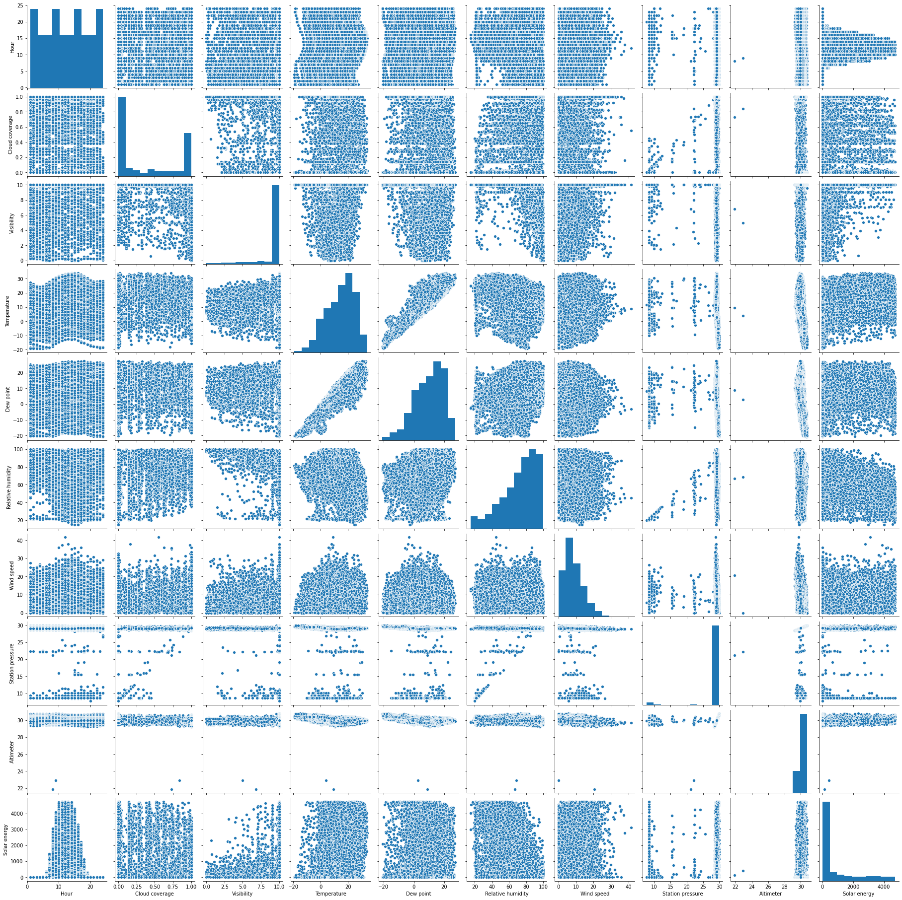

**Heatmap**

A **heatmap** is a graphical representation of data that uses a system of color-coding to represent different values

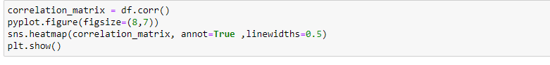

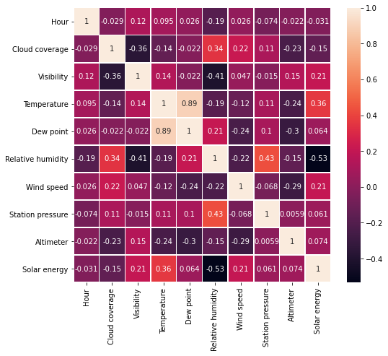

Now we will remove the night hours and plot the heatmap and pairplots for this dataset.

In this dataset,we had an extra column ‘random’ which we used for training.We drop it from the table and proceed with our analysis

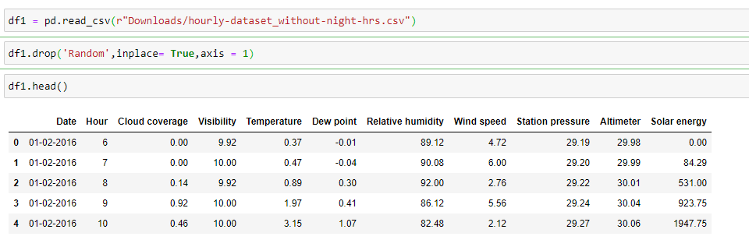

**Pairplot**

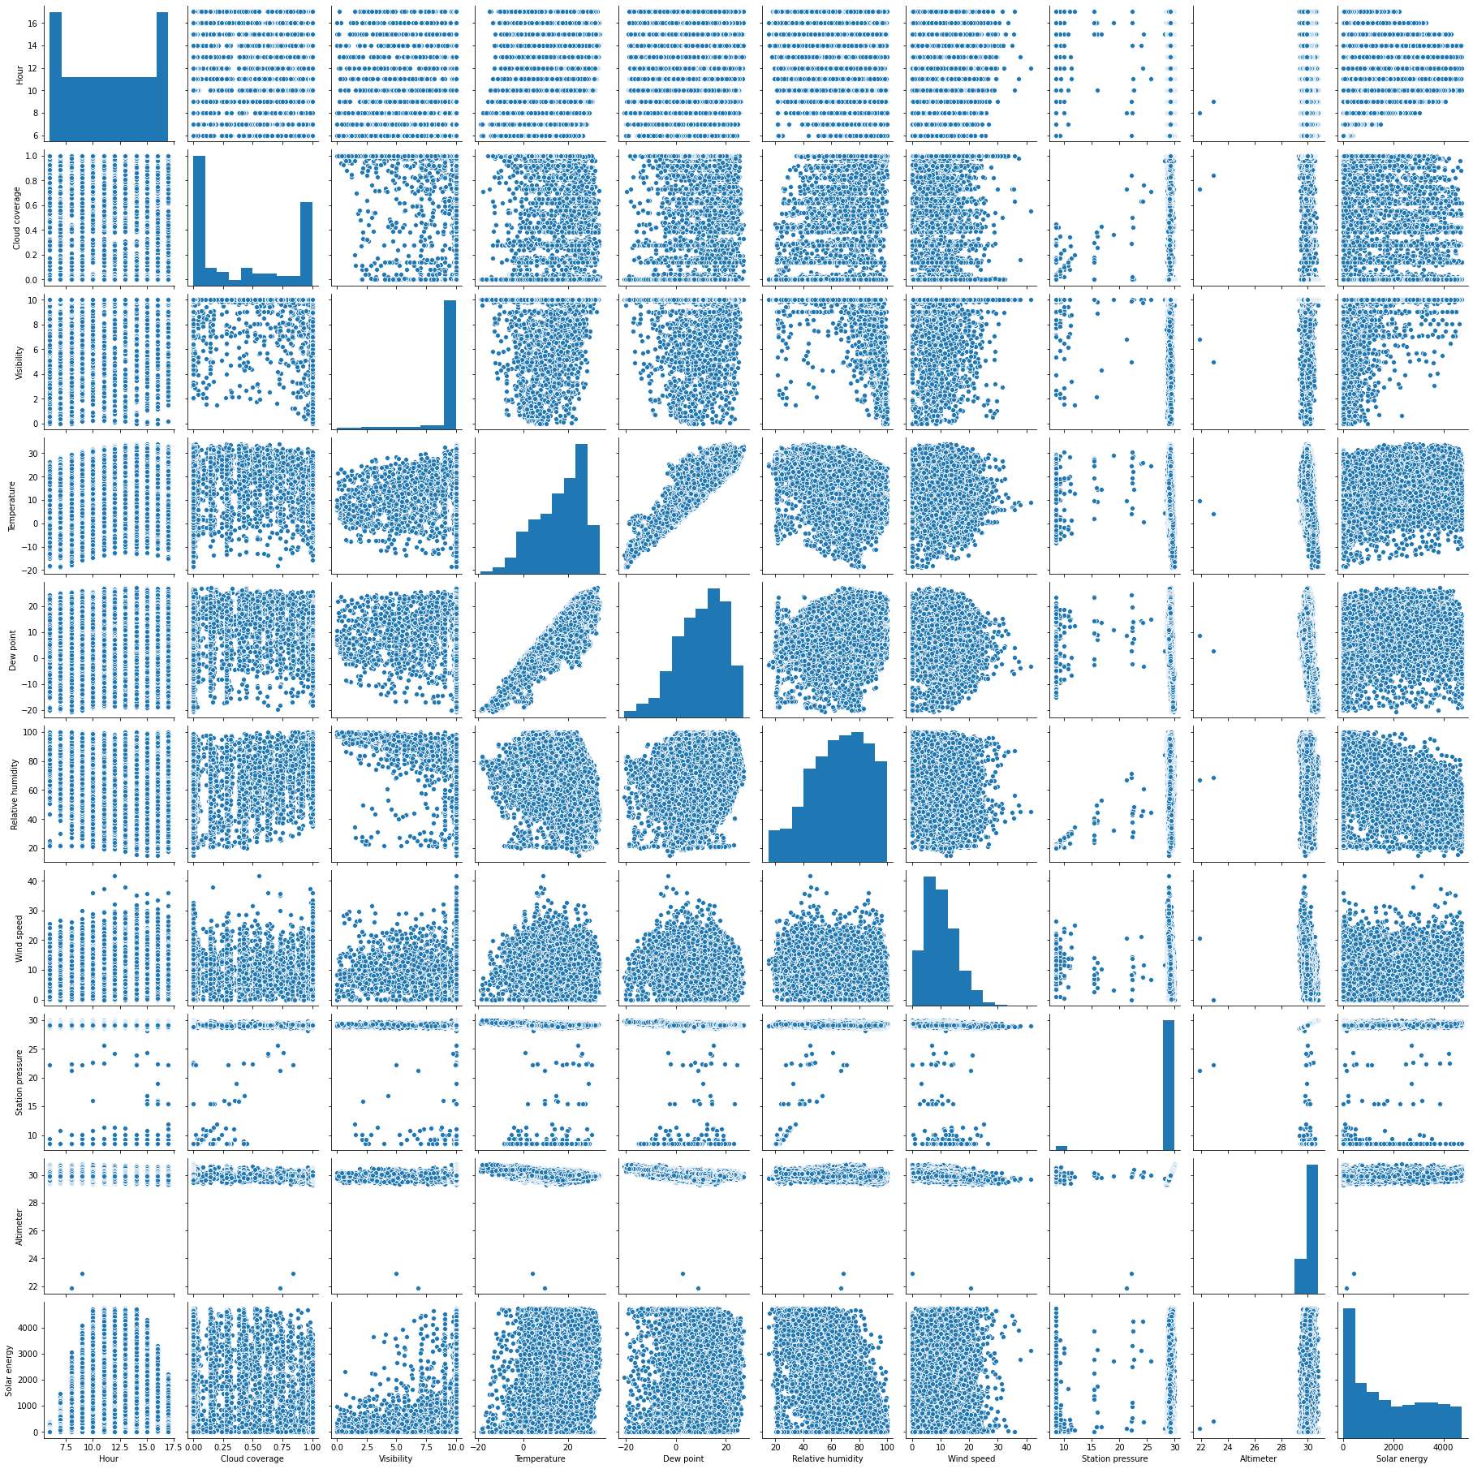

**Heatmap**

